CSA0711 Computer Networks
Assignment
Assignment Title | Analyze Protocol Behaviour and Measure Network Performance Across Alternative Topologies Using Simulation
Course Outcome(s) – CO | · CO3: Analyze and compare the performance of core network protocols such as TCP, UDP, HTTP, and DNS under varying conditions.  · CO4: Design network topologies star, mesh, bus, and hybrid using networking devices, transmission media, and cabling standards  · CO5: Measure network performance using key metrics with simulation tools
Bloom's Taxonomy Level | L5 – Evaluate; L6 – Create
SDG Mapping | SDG 9 – Industry, Innovation and Infrastructure;

1. Develop, implement/simulate, and evaluate a campus or enterprise network in which different applications generate different traffic characteristics. The network shall contain at least four interconnected segments and a minimum of 40 end devices. Design four alternative network structures—star, mesh, bus, and hybrid—using appropriate networking devices, transmission media, and cabling standards. Implement the selected network design in a suitable simulation tool such as Packet Tracer, GNS3, EVE-NG, or equivalent. Conduct controlled experiments to analyze TCP, UDP, HTTP, and DNS under at least three varying network conditions such as low traffic, high traffic, increased delay, packet loss, or link congestion. Measure a minimum of five key network performance metrics, including appropriate combinations of latency, throughput, packet loss, delay, jitter, utilization, and successful delivery rate. Repeat tests where appropriate, organize the measured data in tables and graphs, compare protocol and topology performance, identify bottlenecks, and justify the final topology and engineering decisions based on measured simulation results.
Detailed Assessment Rubric with Performance Levels (Mapped to Assignment Requirements)
Assessment Criterion | Marks | Level 4 (Exemplary) | Level 3 (Proficient) | Level 2 (Developing) | Level 1 (Beginning)
1. Problem Understanding & Network Requirements | 10 | Clearly identifies application needs, traffic patterns, topology constraints, device/media requirements, performance objectives and test conditions. | Identifies most requirements with minor omissions. | Identifies basic requirements but lacks depth. | Requirements are incomplete or poorly understood.
2. Protocol Performance Analysis | 20 | Systematically analyzes TCP, UDP, HTTP and DNS under multiple controlled conditions and explains differences using quantitative and qualitative evidence. | Provides a sound comparison with adequate evidence. | Provides a basic comparison with limited evidence. | Analysis is inaccurate, superficial, or unsupported.
3. Topology Design & Network Infrastructure | 15 | Creates technically correct star, mesh, bus and hybrid topologies and selects appropriate networking devices, media and cabling standards with clear justification. | Most topology and infrastructure choices are appropriate. | Basic designs are present but contain gaps or weak justification. | Designs are incomplete or technically unsuitable.
4. Simulation Implementation & Experiment Design | 15 | Builds the proposed network and controlled experiments in a suitable simulator; test cases are repeatable, clearly defined and technically valid. | Implementation and experiments are mostly correct. | Simulation is functional but experiments are limited or poorly controlled. | Simulation or experiment design is incomplete.
5. Network Performance Measurement | 15 | Accurately measures multiple metrics such as latency, throughput, packet loss, jitter, delay and/or delivery rate; results are organized and repeatable. | Measures appropriate metrics with adequate accuracy. | Measures a limited set of metrics or has weak measurement methodology. | Performance metrics are missing, inaccurate, or not reproducible.
6. Results Interpretation & Engineering Decisions | 10 | Uses tables/graphs to interpret results, identifies bottlenecks and trade-offs, and recommends topology/protocol choices based on measured evidence. | Interprets results and gives reasonable recommendations. | Provides limited interpretation or weak recommendations. | Conclusions are unsupported by measured results.
7. Broader Considerations & Professional Responsibility | 5 | Considers reliability, scalability, standards, efficient resource use, responsible experimentation, and practical network deployment considerations. | Addresses most broader considerations adequately. | Limited discussion of broader design or professional considerations. | Negligible consideration of broader impacts.
8. Technical Documentation & Reflection | 10 | Provides a professional report with diagrams, methodology, configurations, raw/processed results, limitations, references and a thoughtful 300–500 word reflection. | Complete report and reflection with good clarity. | Documentation or reflection lacks depth. | Poor, incomplete, or missing documentation/reflection.

TOTAL 100
Deliverables
To receive full credit, each submission must include the following deliverables:
- Pseudo code
- Implementation & Results
3. Github Upload

1. Problem Statement and Problem Formulation
Design and simulate a campus/enterprise computer network consisting of at least four interconnected network segments and a minimum of 40 end devices. Four alternative network topologies—Star, Mesh, Bus, and Hybrid—shall be designed using suitable networking devices, transmission media, and cabling standards.
The designed networks shall be implemented using Cisco Packet Tracer, GNS3, EVE-NG, or an equivalent network simulation tool. Controlled experiments shall be conducted using TCP, UDP, HTTP, and DNS traffic under different network conditions such as low traffic, high traffic, increased delay, packet loss, and congestion.
The performance of each topology and protocol shall be evaluated using at least five metrics, such as:
- Latency
- Throughput
- Packet loss
- Delay
- Jitter
- Network utilization
- Successful delivery rate
The experimental results shall be represented using tables and graphs. Based on the measured performance, bottlenecks shall be identified and the most suitable topology shall be selected and justified.

2. Objectives
- To understand different computer network topologies.
- To design Star, Mesh, Bus, and Hybrid network structures.
- To create a campus/enterprise network containing 4 interconnected segments and 40+ devices.
- To implement the selected network using a network simulation tool.
- To generate and analyze TCP, UDP, HTTP, and DNS traffic.
- To test network performance under different traffic conditions.
- To measure at least five network performance metrics.
- To compare the performance of different topologies.
- To identify network bottlenecks and failure points.
- To justify the final topology based on experimental results.

3. Proposed Network Scenario
You can use a University Campus Network.
Four Network Segments
Segment | Department | End Devices
Segment 1 | Computer Science | 10 PCs
Segment 2 | Administration | 10 PCs
Segment 3 | Library | 10 PCs
Segment 4 | Engineering/Laboratory | 10 PCs
Total |  | 40 PCs
Additionally, you can include:
- 4 switches
- 1 or 2 routers
- 1 DNS server
- 1 HTTP/Web server
- Wireless access point
- Network monitoring PC
This gives you a realistic campus network.

4. Four Alternative Network Structures
A. Star Topology
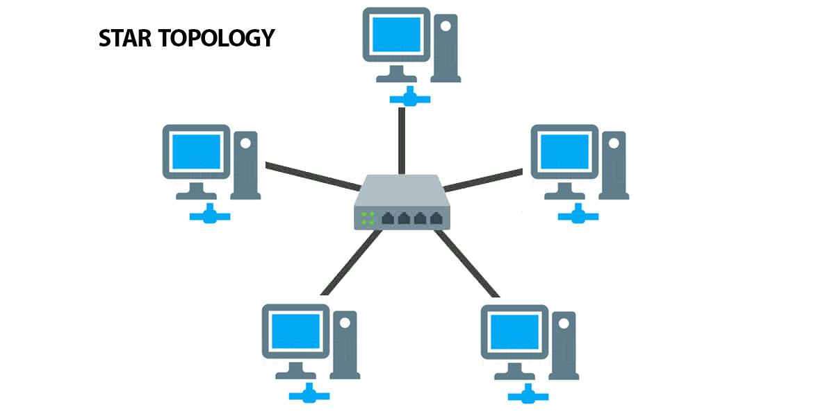

4
All devices are connected to a central switch.
Advantages:
- Easy to configure
- Easy troubleshooting
- Failure of one cable affects only one device
- Good scalability
Disadvantage:
- Central switch is a single point of failure.

B. Mesh Topology
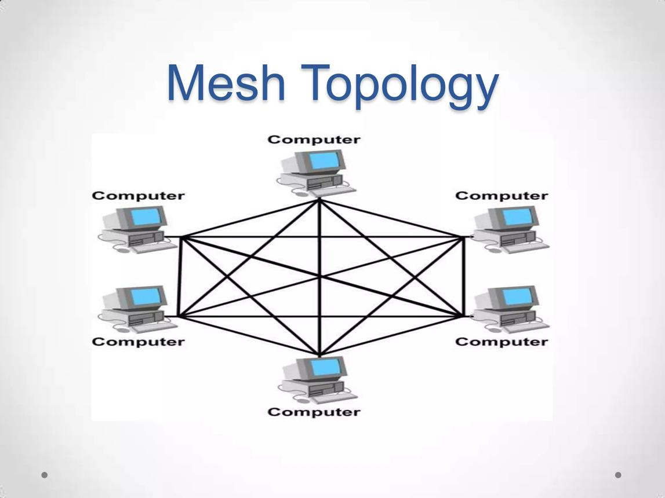

4
Network devices have multiple connections with each other.
Advantages:
- High redundancy
- Excellent fault tolerance
- Multiple paths available
Disadvantages:
- Expensive
- Requires more cables and ports
- Complex configuration

C. Bus Topology
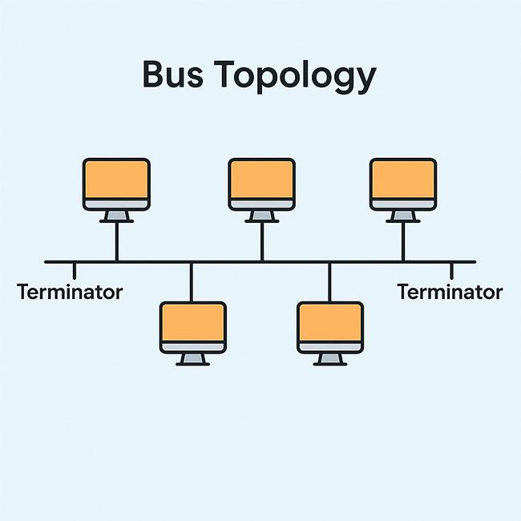

5
All devices share a common backbone cable.
Advantages:
- Simple
- Low initial cost
- Requires less cabling
Disadvantages:
- Backbone failure affects the network
- High traffic causes congestion
- Difficult troubleshooting
- Poor scalability
In modern Packet Tracer implementations, bus topology may need to be simulated conceptually because contemporary Ethernet LANs generally use switches rather than traditional coaxial bus networks.

D. Hybrid Topology

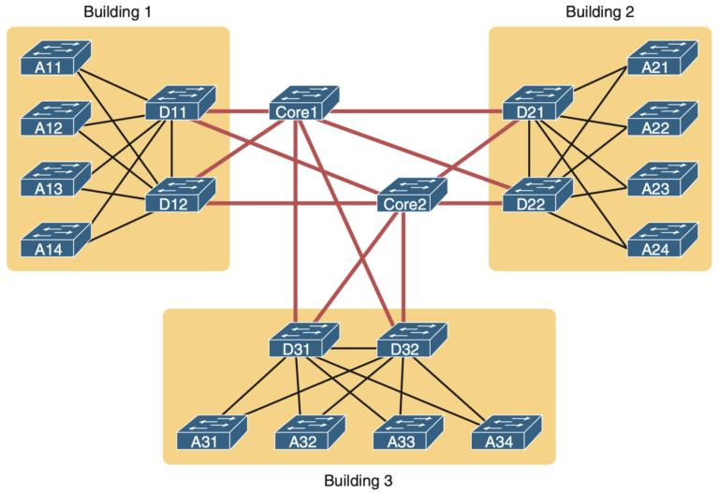

6
Combine two or more topologies.
For your project, use:
Star + Mesh
Example:
CORE ROUTER
/ | \
/ | \
Switch1 Switch2 Switch3
| | |
10 PCs 10 PCs 10 PCs

|
Switch4
|
10 PCs
This is likely to be your final recommended topology because it provides a good balance between performance, reliability, scalability, and cost.

5. Network Architecture
A simple architecture can be:
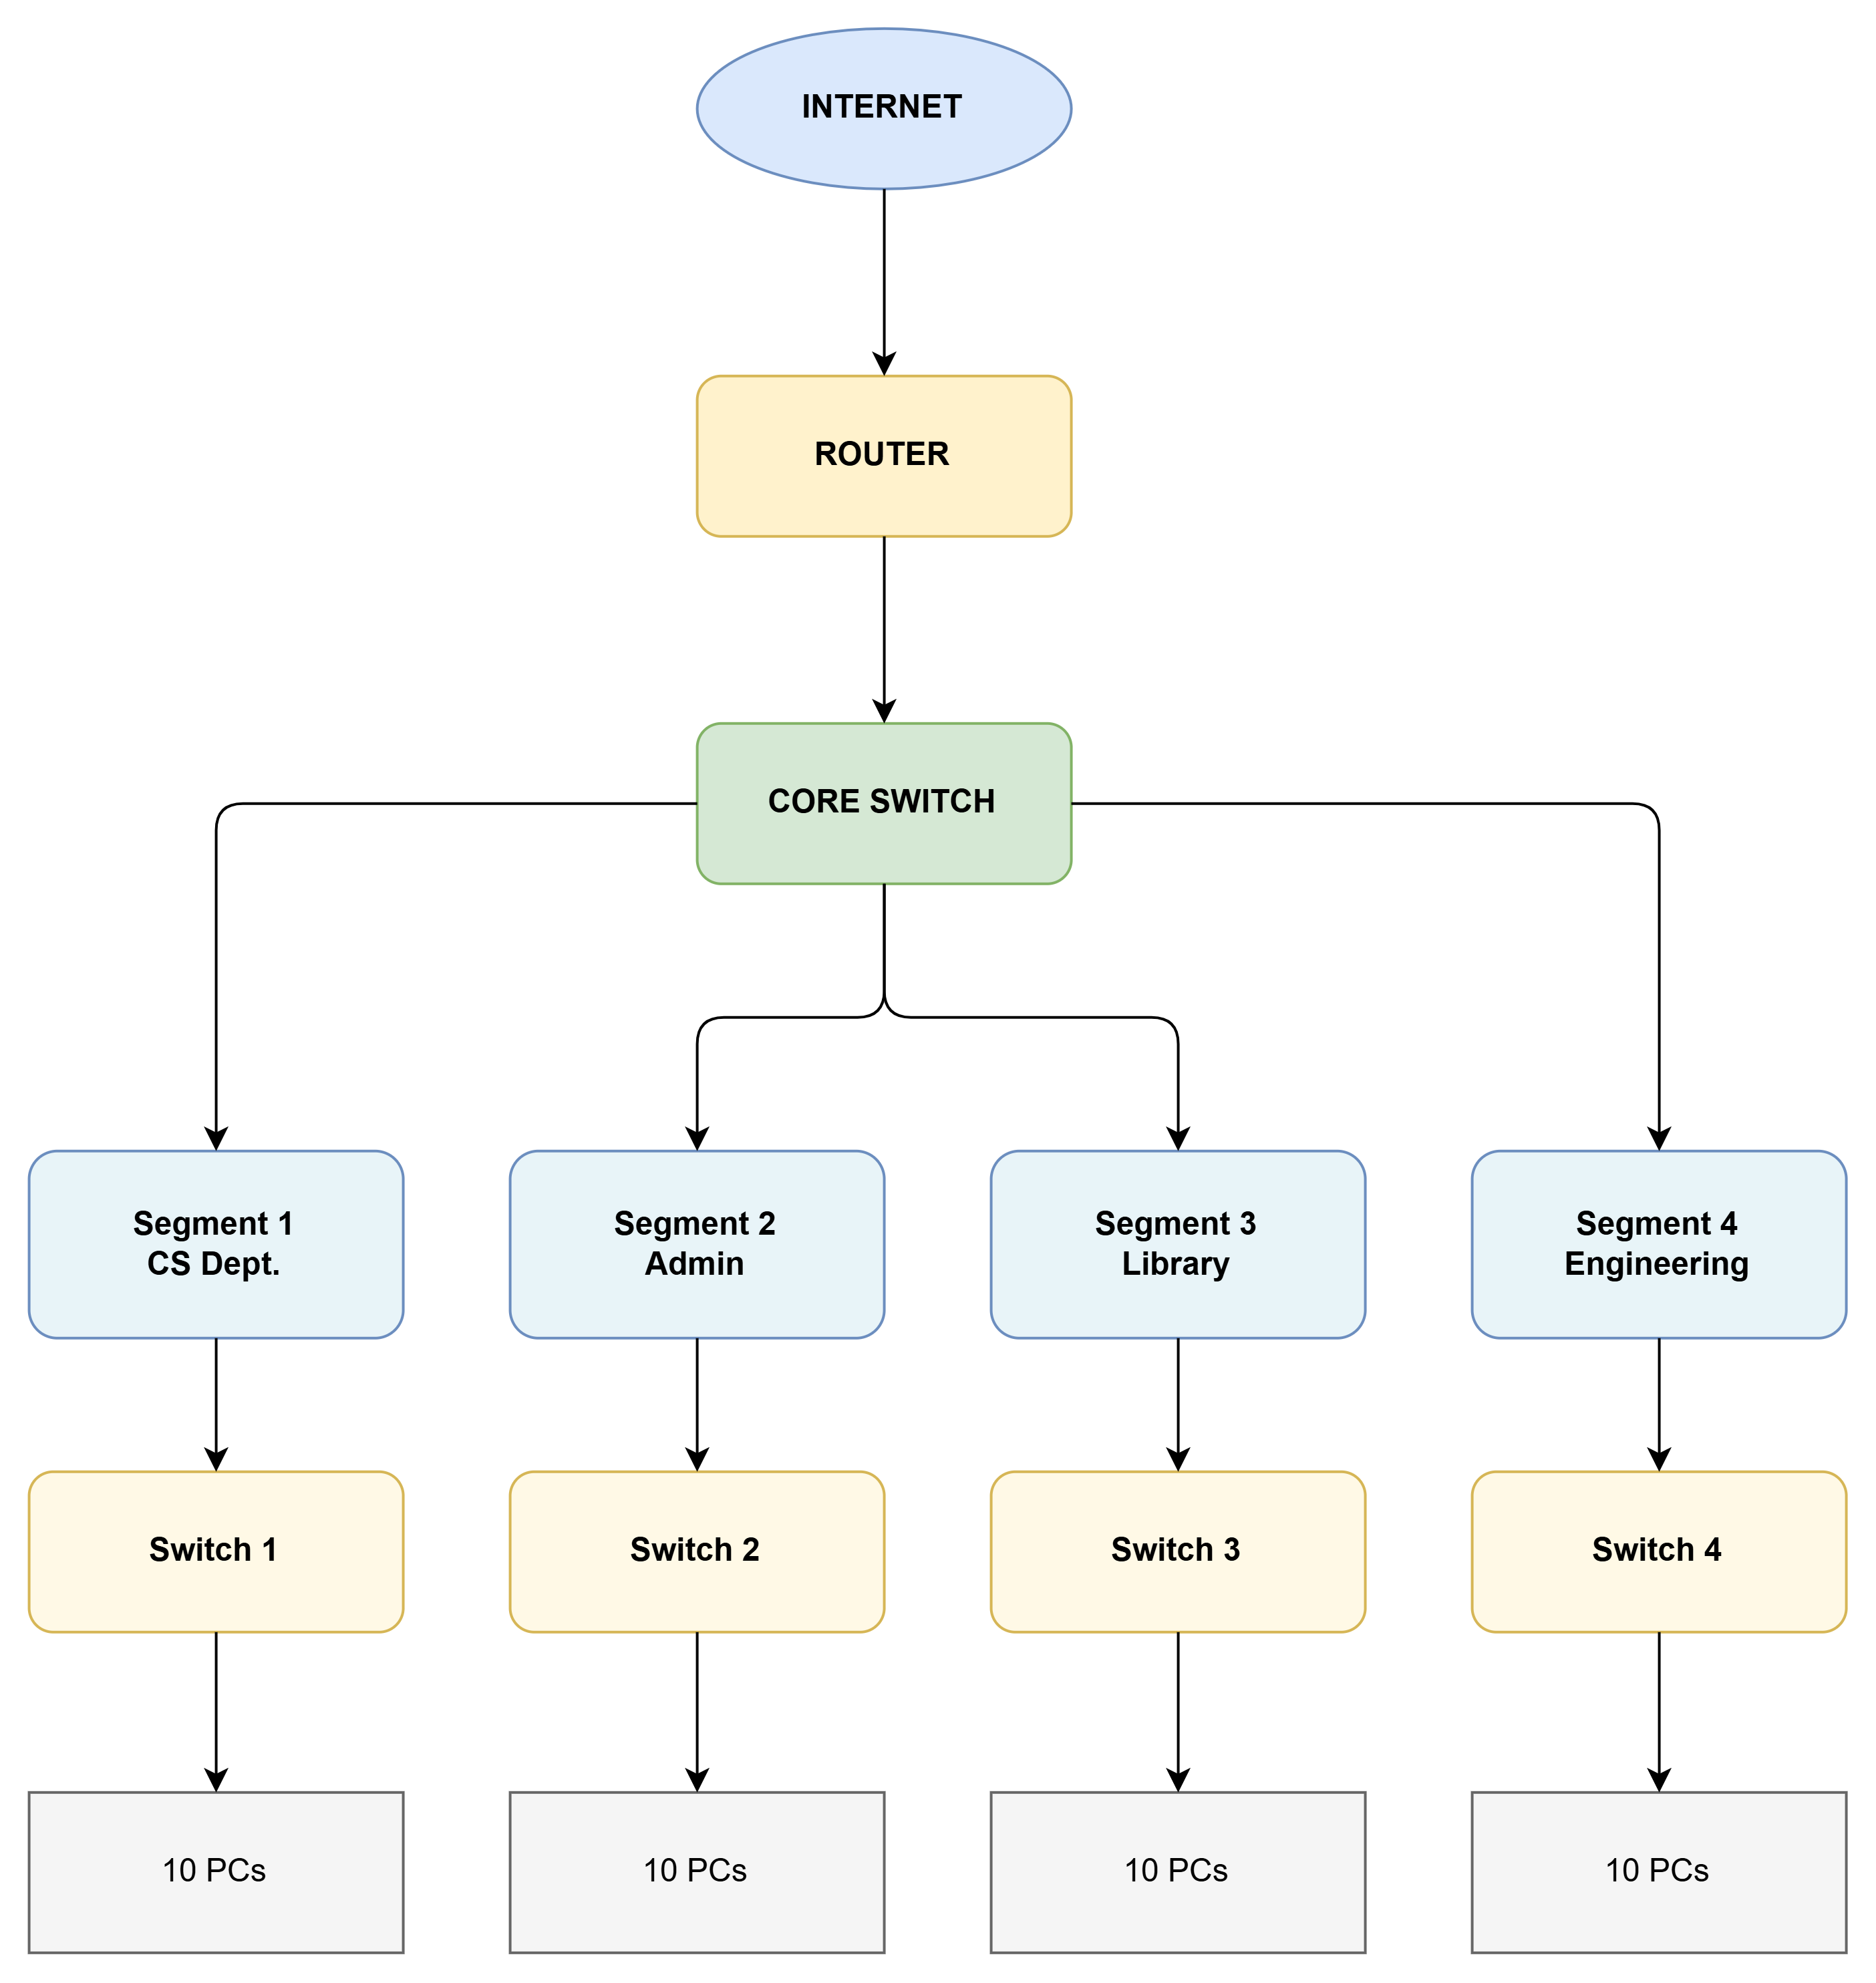

Servers
Connect servers to the core network:
CORE SWITCH
/ \
/ \
DNS SERVER HTTP SERVER

6. Networking Devices
Device | Quantity
Router | 1–2
Switch | 4–5
PCs | 40+
DNS Server | 1
HTTP Server | 1
Wireless AP | 1 optional
End-user devices | 40+

7. Transmission Media
Use appropriate media such as:
Ethernet
UTP Cat6 cable
Used for:
- PC → Switch
- Server → Switch
- Switch → Router
Fiber Optic
Can be used between:
- Core switch → Distribution switches
This gives you a more realistic campus network.

8. Cabling Standards
Mention:
- IEEE 802.3 – Ethernet
- IEEE 802.3u – Fast Ethernet
- IEEE 802.3ab – Gigabit Ethernet
- IEEE 802.3z – Gigabit Ethernet over fiber
- TIA/EIA-568 – Structured cabling standard
For your simulation, you can primarily use Copper Straight-Through Ethernet connections.

9. IP Addressing Plan
Use different subnets for the four segments.
Segment | Network | Example Gateway
CS | 192.168.10.0/24 | 192.168.10.1
Administration | 192.168.20.0/24 | 192.168.20.1
Library | 192.168.30.0/24 | 192.168.30.1
Engineering | 192.168.40.0/24 | 192.168.40.1
Servers:
DNS Server → 192.168.10.10
HTTP Server → 192.168.10.20

10. Protocols to Analyze
Your assignment specifically requires four protocols.
TCP
Used for reliable communication.
Examples:
- HTTP
- File transfer
- Web applications
Measure:
- Latency
- Throughput
- Packet loss
- Delivery rate

UDP
Used for fast, connectionless communication.
Examples:
- Streaming
- Voice/video
- Real-time applications
Measure:
- Delay
- Jitter
- Packet loss
- Throughput

HTTP
Used for web communication between clients and web servers.
Example:
Student PC
↓
HTTP Request
↓
HTTP Server
↓
HTTP Response

DNS
Converts domain names into IP addresses.
Example:
student.com
↓
DNS Server
↓
192.168.10.20

11. Experimental Conditions
You need at least three varying network conditions.
I recommend using four so your report looks stronger.
Condition | Description
C1 | Low Traffic
C2 | High Traffic
C3 | Increased Delay
C4 | Packet Loss/Congestion
Condition 1 – Low Traffic
Small number of packets/users.
Expected:
- Low latency
- Low packet loss
- High successful delivery
Condition 2 – High Traffic
Generate multiple simultaneous flows.
Expected:
- Increased latency
- Increased utilization
- Reduced throughput
- Possible packet loss
Condition 3 – Increased Delay
Introduce artificial delay on a link.
Expected:
- Higher latency
- Lower effective performance
- TCP performance degradation
Condition 4 – Packet Loss
Introduce packet loss on a network link.
Expected:
- Reduced successful delivery
- TCP retransmissions
- UDP packet loss
- Increased application response time

12. Performance Metrics
Use at least five.
I recommend measuring all seven:
Metric | Meaning
Latency | Time taken for data to reach destination
Throughput | Amount of data successfully transmitted per unit time
Packet Loss | Packets that fail to reach destination
Delay | Time required for packet transmission
Jitter | Variation in packet delay
Utilization | Percentage of network capacity being used
Delivery Rate | Percentage of successfully delivered packets

13. Test Case Table
You can use a table like this in your report.
Test ID | Topology | Protocol | Condition | Latency | Throughput | Packet Loss | Jitter | Delivery Rate
T1 | Star | TCP | Low | Record | Record | Record | Record | Record
T2 | Star | UDP | Low | Record | Record | Record | Record | Record
T3 | Star | HTTP | High | Record | Record | Record | Record | Record
T4 | Star | DNS | High | Record | Record | Record | Record | Record
T5 | Mesh | TCP | Low | Record | Record | Record | Record | Record
T6 | Mesh | UDP | High | Record | Record | Record | Record | Record
T7 | Bus | TCP | High | Record | Record | Record | Record | Record
T8 | Hybrid | HTTP | High | Record | Record | Record | Record | Record
Important: Do not invent the values. Record the actual values obtained from your simulation.

14. Algorithm / Pseudocode
Network Performance Evaluation
BEGIN

Create four network topology models
Star
Mesh
Bus
Hybrid

For each topology

Configure network devices

Assign IP addresses

Configure routing

Configure DNS server

Configure HTTP server

Verify connectivity using Ping

FOR each protocol
TCP
UDP
HTTP
DNS

FOR each network condition
Low Traffic
High Traffic
Increased Delay
Packet Loss

Generate network traffic

Collect performance measurements

Calculate:
Latency
Throughput
Packet Loss
Delay
Jitter
Utilization
Delivery Rate

Store results

END FOR

END FOR

END FOR

Compare all topology results

Identify bottlenecks

Select best-performing topology

Justify final topology based on
performance, reliability and cost

END

15. Flowchart
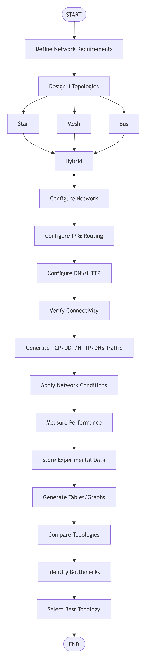
16. Graphs to Include
For the evaluation, create graphs such as:
Graph 1
Topology vs Average Latency
Star █████
Mesh ████
Bus ███████
Hybrid ███
Graph 2
Topology vs Throughput
Graph 3
Topology vs Packet Loss
Graph 4
Protocol vs Latency
Compare:
TCP
UDP
HTTP
DNS
Graph 5
Network Condition vs Delivery Rate
You can create these graphs using Excel after collecting your simulation results.

17. Expected Analysis
Your analysis should discuss why the results occurred.
For example:
Star
Generally provides good performance because each end device has a dedicated link to the switch. However, the central switch can become a bottleneck.
Mesh
Provides multiple communication paths and strong fault tolerance. However, the large number of links increases cost and configuration complexity.
Bus
Can experience greater congestion because devices share the same communication medium. It becomes less suitable as traffic and number of devices increase.
Hybrid
Combines the advantages of different topologies and can provide good scalability and reliability while avoiding the excessive cabling of a full mesh.

18. Bottleneck Identification
Look for:
- Highly utilized links
- Increased packet loss
- High latency
- High jitter
- Reduced throughput
- Server overload
- Congested switch/router interfaces
Example:
40 PCs
↓
Access Switch
↓
100 Mbps Link
↓
Core Switch
If many users simultaneously transmit through the same 100 Mbps link, it may become a bottleneck.

19. Final Topology Selection
A suitable conclusion could be:
Based on the experimental measurements, the hybrid topology is selected as the final network architecture because it provides a suitable balance between performance, scalability, reliability, fault tolerance, and implementation cost. Although mesh topology provides better redundancy, its cabling and configuration requirements are significantly higher. Star topology provides simple management but depends heavily on the central switching infrastructure. Bus topology is less suitable for high-traffic campus environments because of shared-medium congestion. Therefore, the hybrid topology provides the most practical solution for the proposed campus network.

20. DAA Connection
Since this is a DAA assignment, don't make the report only about networking.
Connect it to algorithm analysis and performance evaluation.
You can state:
- Network routing involves path-selection algorithms.
- Topology comparison involves systematic performance analysis.
- Traffic generation and measurement involve experimental algorithm evaluation.
- Repeated experiments improve reliability of performance estimates.
- Bottleneck identification is similar to identifying computational/network resource constraints.
- Performance metrics allow empirical comparison of alternative solutions.
- Trade-off analysis considers performance versus cost and complexity.

21. Individual Contribution – 3 Students
Student 1 – Network Design and Topology
Responsible for:
- Problem formulation
- Designing Star, Mesh, Bus and Hybrid topologies
- IP addressing
- Network devices
- Cabling and architecture
- Packet Tracer implementation
Student 2 – Protocol and Traffic Analysis
Responsible for:
- TCP experiments
- UDP experiments
- HTTP experiments
- DNS experiments
- Traffic-condition configuration
- Test-case execution
- Data collection
Student 3 – Performance Evaluation and Documentation
Responsible for:
- Latency analysis
- Throughput analysis
- Packet-loss analysis
- Jitter and utilization analysis
- Graph generation
- Topology comparison
- Bottleneck identification
- Final conclusion and documentation
All three members should participate in testing and validation.

22. Individual Reflection
Each student needs a separate one-page reflection.
Use this structure:
Student Reflection
1. My Contribution
Describe the module/tasks you personally completed.
2. Design Decisions
Explain why you selected particular devices, protocols, topology, IP addressing, etc.
3. Challenges Faced
Mention problems such as configuration errors, connectivity problems, traffic generation, or measurement difficulties.
4. Learning Gained
Explain what you learned about networking, simulation, protocols, topology, and performance analysis.
5. SDG Connection
Explain how reliable and efficient digital infrastructure supports SDG 9 – Industry, Innovation and Infrastructure.
6. CO Attainment
Explain how completing the assignment helped you achieve the mapped Course Outcome.
23. SDG Relevance
The strongest connection is:
SDG 9 – Industry, Innovation and Infrastructure
The project contributes to SDG 9 by studying the design and optimization of reliable digital communication infrastructure. Evaluating network performance under different conditions helps improve the efficiency, scalability, and reliability of communication systems used by universities and enterprises.
You can also mention:
SDG 4 – Quality Education
A reliable campus network supports:
- Online learning
- Digital classrooms
- Online examinations
- Learning management systems
- Access to educational resources

